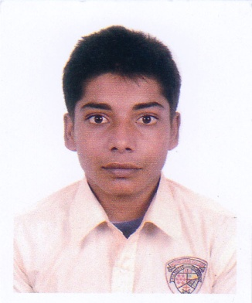
Resume of
Pallab Biswas
House- 212, Road-09, Section- 13,
Kafrul, Mirpur, Dhaka-1216.
Cell : +8801786 065 961
E-mail : pallabsbiswas24@gmail.com

Career Objective:

To serve in responsible administrative position at well- structured organization and my successfully apply my acquired managerial and interpersonal skills to enhance organizational efficiencies.

EDUCATIONAL QUALIFICATION:

Hon’s

University : University of Dhaka
Institution : Govt. Bangla College
Department : Economics
Result : 1st Year Running

H.S.C

Institute : Notre Dame College
Board : Dhaka
Group : Humanities
Result : GPA-4.17 (Out of 5)
Year : 2018

S.S.C

Institute : Mujibnagar Amrokanon High School
Board : Jessore
Group : Humanities
Passing Year : 2016
Result : GPA-3.78 (Out of 5)

Computer Skills
• Microsoft Word, Microsoft Excel, Microsoft Power Point
Adobe Photoshop, Adobe Illustrator.
• Operating System : Windows-Xp, Win-7, Win-8, Win-10
• Internet : Good knowledge on Browsing & E-mail

Language Profiiency
Bangla : Mother tongue.
English : Fluent in reading, writing, Listening and speaking.
Personal Details :

Name : Pallab Biswas
Father's Name : Nirmal Biswas
Mother's Name : Mallicka Biswas
Permanent Address : Village: Bhabarpara, P.O.- Mujibnagar,
P.S- Mujibnagar, District- Meherpur.

Date of Birth : 30th May,2001

Nationality : Bangladeshi (By birth)
Religion : Christian
Gender : Male
Marital Status : Unmarried
Blood Group : AB+
Height : 5`-4``

Personal Attributes

- Try to use full of my efficiency in fulfilling deadline
- Willing to accept responsibility & perform accordingly
- adaptability to new & challenging situation
- Always try to punctual & honest.
Work Experience
- As a Receptionist at Tahar Clinic 2015 to 2017
- 2 years experience in Digital Marketing

Signature

(Pallab Biswas) Date :

