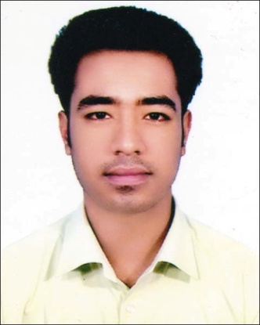
RESUME OF
GOBINDA RAJBANGSHI
Ufulki , Jamurki
Mirzapur, Tangail, Dhaka,
Bangladesh
Contact No: 01625931544/ 01928633179
E-mail: gobindaraj003@gmail.com

Career Objective

A responsible position providing for career growth, utilizing innovative skills, compatibility with others and educational experience. Desire to contribute effectively through facing new challenging responsibilities and work independently in an environment where professionalism & responsibility are of prime concern.

KEY QUALITIES

- Able to work under pressure.
- Have a good inter-personal communication skill.
- Analytical ability.
- Multitasking & able to keep confidentialities.

Educational Qualification

Exam  Title | Concentration/Major | Institute | Result | Pass.Year | Achievement
SSC | Science | Barati Nardana  Bangladesh High School | GPA:4.94  out of 5 | 2013 | Bangladesh Education Board
Diploma | Telecommunication Technology | Tangail Polytechnic Institute | CGPA:3.15 | 2018 | Bangladesh Technical Education Board

Training Summary:

Training Title | Topic | Institute | Country | Location | Year | Duration
Industrial training | Graphics Design | NTC | Bangladesh | Tangail | 2017 | 3 months

Language Proficiency

- Language Speaking Reading Writing
- Bangla Excellent Excellent Excellent
- English Good Excellent Excellent

Computer Skills

- Office: Microsoft Word, Excel, Power- Point, Office Access
- Graphics Design: Photoshop CC 2017, Illustrator CC 2017
- Mobile Servicing
- Internet: E-mail, Browsing
Activities and Interests:

- Reading Poem & Novel related books to gather knowledge.
- Internet Browsing.
- Traveling.

Personal Details

- Name : Gobinda Rajbangshi

- Father’s name : Ramesh Rajbangshi

- Mother’s name : Shuva Rani Rajbangshi

- Date of Birth : 02 November,1996

- Permanent Address : Vill: Ufulki P.O: Barati
P.S : Mirzapur Dist: Tangail

- Present Address : 801/3, West Kazi para, Mirpur, Dhaka 1216.

- Nationality : Bangladeshi (by birth).
- Sex : Male
- Marital Status : Unmarried
- Religion : Hindu
- Blood Group : A+ ( “ A ” positive)

Certification

I, the undersigned, certify that according to the best of my knowledge and belief, this resume correctly describes my qualifications, and me.

EXPERIENCE.

Computer Operator
Bangladesh It Institute

REFERANCE:
- Engr. Nurun Nahar Begum
Head of the Department, TCT
Mobile: 01743900440

- Engr. MD. Anayat Karim
Workshop Super(TCT)
Mobile: 01815882119

- Chandan Kumar Sarker
Assistant Engr.
Shahrin Group
Mobile: 01782804015

Gobinda
(Gobinda Rajbangshi)
Date: 09/08/2018

