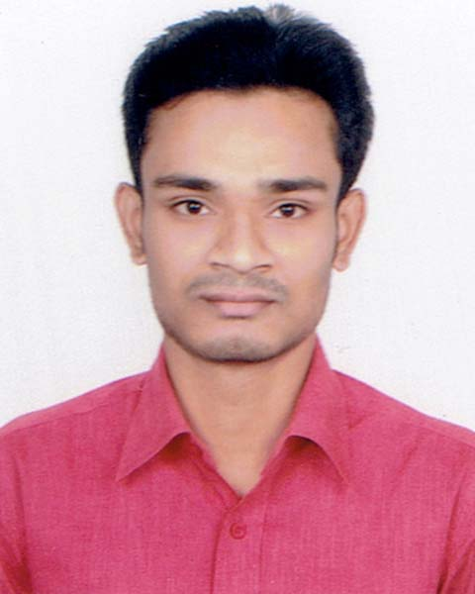
RESUME

OF

GAYARAM SAHA

Contact Address: 14/1, Road 2,
Shyamoli, Dhaka-1207
Contact No: 01776103103
Email: sahagr71@gmail.com

CAREER OBJECTIVE:

I am willing to work where I can share my knowledge and energy to the fullest extent and to work in such an environment that will give me scope to enrich myself with new challenge and opportunities.

ACADEMIC QUALIFICATION:

MA in English (Studying)

BA (Hons) in English
1st Class (CGPA: 3.24)
Passing Year: 2018
ASA University Bangladesh

H.S.C Examination
Group : Science
Result : GPA 4.10
Passing Year: 2014
Institution : Osmanpur Degree College
Board : Dinajpur

S.S.C Examination
Group : Science
Result : GPA 4.38
Passing Year : 2010
Institution : Nurjahanpur R.M.C High School
Board : Dinajpur

COMPUTER LITERACY/SKILLS: Microsoft Word, Microsoft Excel, Microsoft Power Point, Microsoft Access and Internet Explorer.

LANGUAGE PROFICIENCY: Excellent writing and oral communication ability in English & Bengali.

INTERESTE ANA ABILITIES:
Singing, Travelling, Bicycling, Creative Writing,
Able to maintain public relations.

PERSONAL DETAILS :
Father’s Name : Goutam Chandra Saha
Mother’s Name : Chanchala Rani Saha
Permanent Address : Vill :Kadimnagar
P.O :Ghoraghat
P.S :Ghoraghat
Dist :Dinajpur

DATE OF BIRTH : 30 December,1995
NATIONALITY : Bangladeshi
RELIGION : Hindu
GENDER : Male
MARITAL STATUS : Unmarried

REFERENCE :
Dipa Saha
Coin Examiner
Bangladesh Bank
Contact No: 01738772937

DECLARATION

I hereby declare that all the details given above are true to the best of my knowledge and belief.


Gayaram Saha

